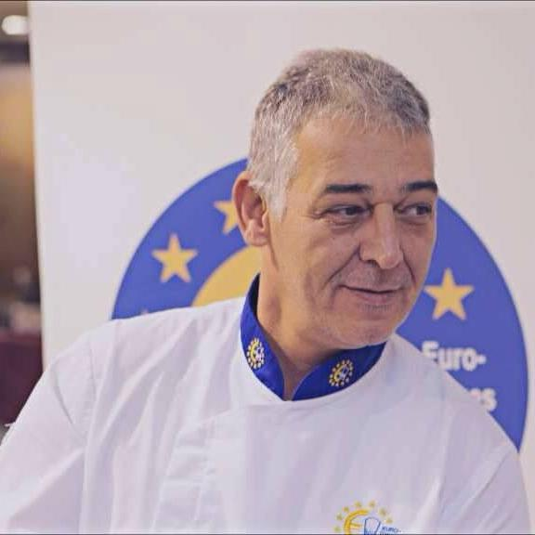

C. V. - Lebenslauf

Name | PARASCHOS
Last Name  - Nachname | AXIOTIS
Date of birth  - Geburtsdatum | 14 th March 1958  14. März 1958
Place of birth  - Geburtsort | Pireaus
Home address  - Adresse | I. Zarkou str. 10 24100 Kalamata
Tel:  Cell  e – mail:  Facebook : | +30 27210 93844  +30 6948046207  chefaxiotis@gmail.com  https://www.facebook.com/paraschos.axiotis
Studies  - Studium | Graduate of the School for Touristic Profession  Institute für turistische Berufe
I.D. Number  - Aus weis nummer  I.K.A. Insurance number  - Versicherungsnummer  AMKA  V.A.T. | 1297481  14035802017
Foreign languages  - Fremde Sprachen | French – German – English  Französisch - Deutsch - Englisch
Other Knowledges  - Andere Kentnisse | Computer

Experiences

 | Company |  |  |  |  | Expertise
2013 | Porto Carras Grand Resort ( Chalkidiki ) |  |  |  |  | Executive CHEF
2012 | Qatar Star Services L.L.C Doha, Qatar |  |  |  |  | Executive CHEF
2011 - 2012 | CRETA MARIS – TERRA MARIS Hersonissos Creta ( All Inclusive ) |  |  |  |  | Executive CHEF
2008 - 2010 | OLYMPIA GOLDEN BEACH Resort & Spa – Kyllini |  |  |  |  | Executive CHEF
2007 – 2008 | MAGIC LIFE KIOTARI IMPERIAL Rodos 1.250 Beds ( All Inclusive ) |  |  |  |  | Executive CHEF
2005 – 2008 Winter | MAGIC LIFE SIRENA ANTALYA Turkey 1.200 Beds ( All Inclusive )
2003 - 2005 | PILOT BEACH HOTEL - Crete |  |  |  |  | Executive CHEF
2001 - 2003 | Telefone Companyy Hall. 3.000 portions daily  Haus der Telefon Kommunikation. 3.000 gerichte täglich. |  |  |  |  | Executive CHEF
1998 - 2001 | In charge for 2 cruise ships. 4.000 portions daily ( All Inclusive ) Epirotiki Line  Hauptverantwortlicher für 2 Kreuzfahrtschiffe. 4.000 gerichte täglich. ( All Inclusive ) |  |  |  |  | Executive CHEF
1996 - 1998 | HOTEL ΄΄ BELLE HELEN ΄΄ ( Βathi - Sparta ) |  |  |  |  | CHEF
1989 - 1996 | HOTEL ΄΄ SCALETA ΄΄ ( Rethymno ) Crete |  |  |  | CHEF
1987- 1989 | HOTEL ΄΄ SCALETA ΄΄ ( Rethymno ) Crete |  |  |  |  |  | Α΄ Koch
1984 - 1986 | Restaurant ΄΄ GRAND PLACE ΄΄ με 2 Fourchette | - Brussels  - Brüssel |  |  |  |  |  | Α΄ Koch
1981 - 1984 | Restaurant ΄΄ ΑCROPOLIS ΄΄ |  |  |  |  |  |  | Α΄ Koch
1979 – 1981 | Restaurant ΄΄ ΑTHANAS ΄΄ |  |  |  |  |  |  | Koch

